BUSINESS ANALYST

What is business analyst ?

The role of a business analyst typically involves understanding and analyzing business processes and identifying areas for improvement or optimization . They may also be involved in project management,requirements gathering ,and stakeholder communication.

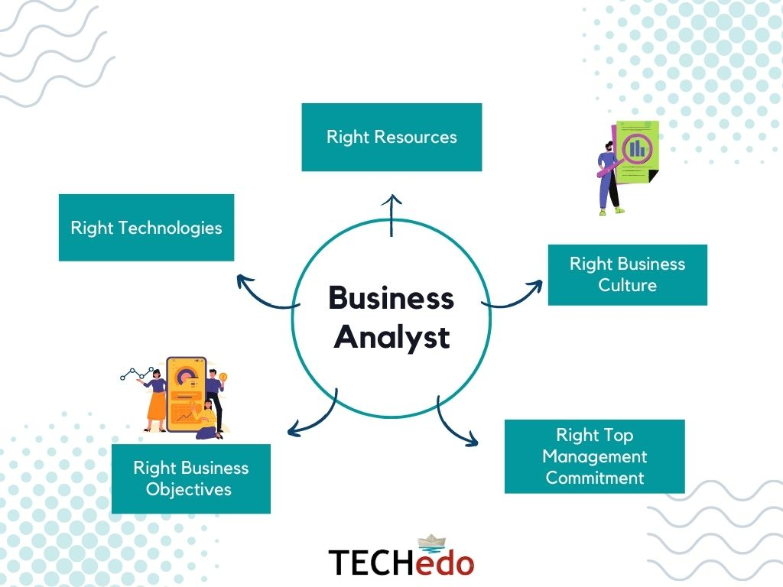

**Here are some of the responsibilities of a business analyst:**

**Analyze data**

Use data modeling to analyze large data sets, and create charts, tables, and other visualizations

**Identify needs**

Understand the organization's functional and technical needs, and prioritize them

**Create models**

Create financial models and other models to support business decisions

**Develop plans**

Plan enterprise architecture, and establish strategies to improve revenue or optimize costs

**Communicate**

Communicate findings and recommendations to stakeholders, and help implement changes

**Document**

Create written documentation to support your work, and report on your findings

**Evaluate**

Evaluate the impact of changes, and oversee and report on the evaluation

**Research**

Research technology advancements to modernize business systems and processes

SOFTWARE DEVELOPMENT LIFE CYCLE

Software development life cycle (SDLC) is a structured process that is used to design, develop, and test good-quality software. SDLC, or software development life cycle, is a methodology that defines the entire procedure of software development step-by-step. The goal of the SDLC life cycle model is to deliver high-quality, maintainable software that meets the user’s requirements.

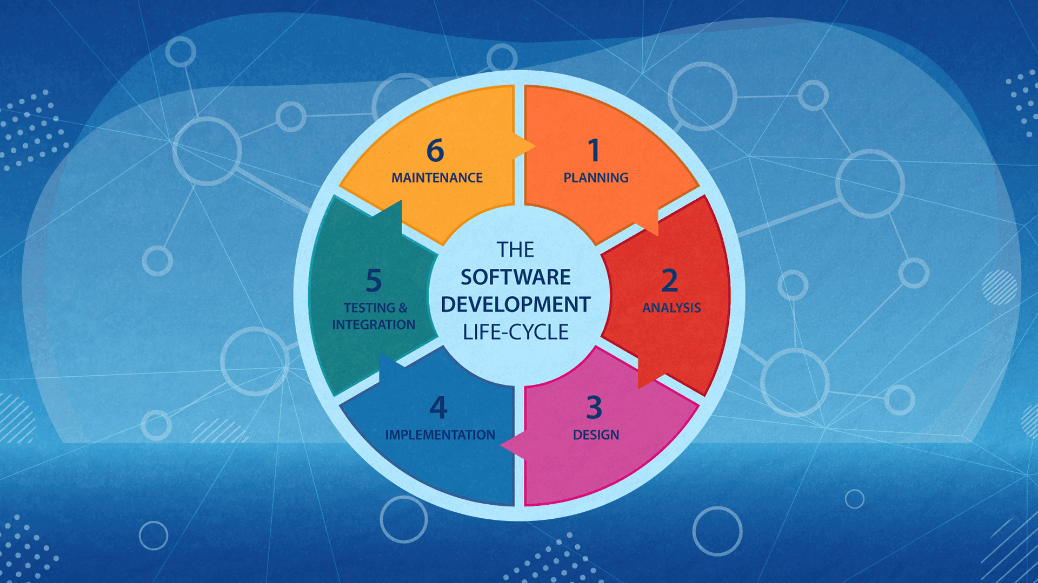

Agile_sprint

An agile sprint is a short, repeatable phase of work in an agile project management framework, such as Scrum or Kanban. Sprints are used to break down large projects into smaller, more manageable chunks. The goal is to deliver new functionality and improvements to customers as quickly as possible.

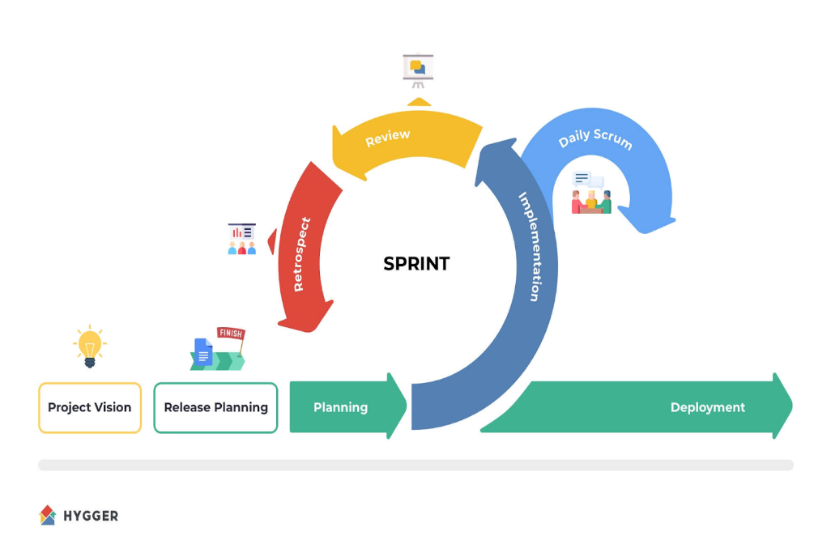

**Here are some characteristics of agile sprints:**

**Length**

Sprints are typically one to four weeks long, but the length can vary by organization.

**Planning**

Sprints begin with a planning meeting where the team agrees on the sprint goals, the work to be completed, and the criteria for acceptance.

**Backlog**

The team selects items from the sprint backlog, which is a list of tasks and changes to be completed during the sprint.

**Iteration**

Teams adapt future sprints based on the outcome of the previous one.

Roles

Agile sprints rely on three roles: the product owner, the scrum master, and the development team.

**Transparency**

Sprint planning meetings include the entire team to ensure everyone is aware of what others are working on.

* **Other terms related to sprints**
  + Sprint planning: A meeting that usually takes place before the start of every sprint. During this meeting, team members select items from the Product Backlog to develop during the sprint.
  + Sprint backlog: A detailed plan that helps to understand the changes in development.
  + Sprint retrospective: A meeting where team members assess their outcomes and working process.
  + Sprint velocity: The average number of tasks or hours logged in to complete a particular sprint.

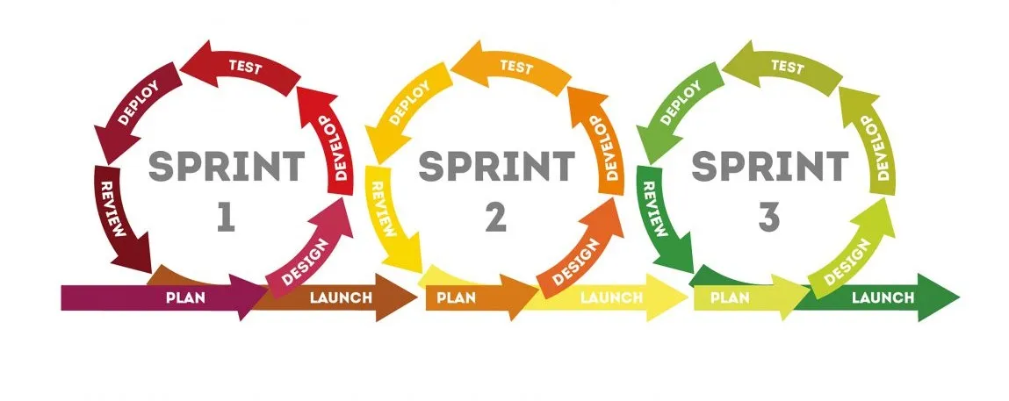

**\*SDLC CYCLE IN AGILE SRINT PLANING**

**TRAYA HAIR OIL PRODUCT ONLINE PLATFORM**

* + **Objective**:- Build ,test and launch a traya hair oil platform or features related to the product (eg, e-commerce,customer reviews, subscription models),develop an e-commerce platform, marketing strategies, and product enhancement solutions.
  + **Sprint duration:-** 4 month sprint planning(8 sprint)
  + **Team members:-**

|  |  |
| --- | --- |
| **Members** | **Number** |
| Project manager | 1 |
| Business analyst | 1 |
| Data analyst | 1 |
| frontend developer | 2 |
| backend developer | 2 |
| UI/UX Designer | 1 |
| QA Tester | 1 |

**Sprint 1 (Week 1-2): Requirement Analysis & Architecture Design**

**Tasks:**

* Finalize platform requirements and scope.
* Define tech stack (e.g., React.js, Node.js, MongoDB, etc.).
* Create wireframes and design mockups.
* Set up the development environment and repository.

**Deliverables**:-

* Wireframes for homepage, product pages, and cart.
* Basic project structure in the repository.

**Sprint 2 (Week 3-4): Backend Development Begins**

**Tasks:**

* Design database schema (products, users, orders, etc.).

Set up backend APIs for:

* Product catalog
* User registration/login

Order placement

**Frontend Tasks**: Build static homepage structure using designs.

**QA Tasks**: Write initial test cases for APIs.

**Sprint 3 (Week 5-6): Frontend-Backend Integration**

**Tasks:**

* Integrate backend APIs with the frontend for:

* Product listing
* User authentication
* Create a dynamic product page layout.

**Deliverables**:

* Functional product listing page.
* Working login/signup system.

**Sprint 4 (Week 7-8): Cart & Checkout Development**

**Tasks:**

* Implement add-to-cart functionality.
* Develop backend logic for order processing.
* UI for cart and checkout process.

**QA Tasks**: Perform end-to-end testing for product to cart flow.

**Sprint 5 (Week 9-10): Payment Gateway Integration**

**Tasks:**

* Integrate a secure payment gateway (e.g., Razorpay, Stripe).
* Set up order confirmation email notifications.

**Frontend Tasks**:

* Design order confirmation and failure screens.

**Deliverables**:

* Fully functional checkout process.

**Sprint 6 (Week 11-12): Mobile Responsiveness**

**Task:-**

* Optimize website for various devices.
* Test UI/UX for mobile and tablet users.

**QA Tasks**:

* Perform cross-browser and cross-device testing.

**Sprint 7 (Week 13-14): SEO & Performance Optimization**

**Tasks:**

* Implement SEO best practices.
* Improve website loading speed (image compression, lazy loading, etc.).

**Deliverables**:

* SEO-optimized product pages.

**Sprint 8 (Week 15-16): Final Testing & Deployment**

**Tasks**:

* Conduct full platform testing.
* Fix critical bugs.
* Deploy the platform to production.

**Deliverables**:

* Live online platform ready for users.